Total Triage Update – What we have learned so far
In October 2025, we introduced a new Total Triage appointment system to help ensure patients are directed to the right care, at the right time, with the right clinician.
We would like to share what we have learned so far, how patients are using the system, and what is working well — as well as the challenges we continue to address.
How the Total Triage system works
All appointment and care requests are made using online triage via AccuRx. Patients are asked to complete and submit a short form, which is then reviewed by the Duty Doctors.
- Online triage can be accessed via the practice website and the NHS App
- The system is available Monday to Friday, 8:00am–6:30pm
- All requests receive a response on the same working day
- For patients who do not have access to the internet or who are unable to use the form, our reception team can complete the form over the telephone on the patient’s behalf
Telephone access – what has changed
Since introducing Total Triage, telephone demand and waiting times have reduced significantly.
1 October 2025 – 23 January 2026
- Calls received: 20,220
- Average queue time: 2 minutes 44 seconds
- Call-back requests: 147
Same period in 2024–2025
- Calls received: 30,456
- Average queue time: 10 minutes 24 seconds
- Call-back requests: 4,062
These figures show that patients are waiting much less time on the phone to contact the practice than before.

Online requests – how patients are contacting us
1 October 2025 – 23 January 2026
- 13,526 total requests submitted
- 9286 were requests for appointments and the remainder were administrative requests including prescriptions, fit notes etc.
For comparison, during the same period in 2024–2025:
- 4,220 requests in total
- 2007 were requests for appointments and the remainder were administrative requests.
This demonstrates that Total Triage has made it easier for patients to contact the practice to request an appointment.
How requests are submitted
October 2025 – January 2026
- 85% via the practice website
- 6% via the NHS App
- 9% completed by reception for patients who need support
In 2024–2025, 91% of requests were submitted via the website and 9% via the NHS App.
What types of requests are submitted
Requests fall into two main categories:
- Medical requests, such as new or ongoing health problems
- Administrative or routine requests, including:
  - Repeat prescriptions
  - Fit notes
  - Test results
  - Reports and letters
  - Routine care queries
Both medical and administrative requests have increased substantially since the introduction of Total Triage.
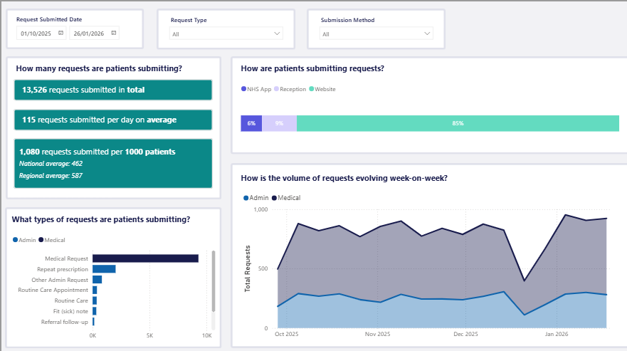

When requests are submitted
Online triage is available Monday to Friday during core hours (8:00am–6:30pm).
The data shows that:
- Mondays are consistently the busiest day
- The highest number of requests are submitted in the morning
- Demand gradually reduces through the afternoon
- Request levels are lowest towards the end of the working day
This information helps us plan staffing and clinical capacity during our busiest times.

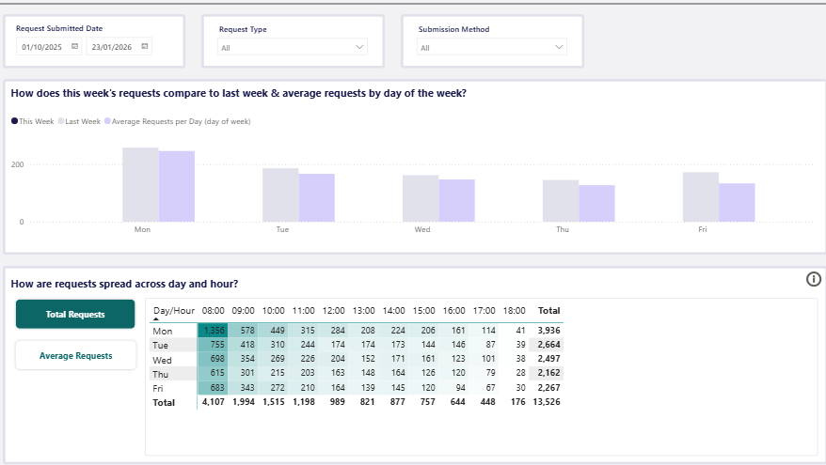
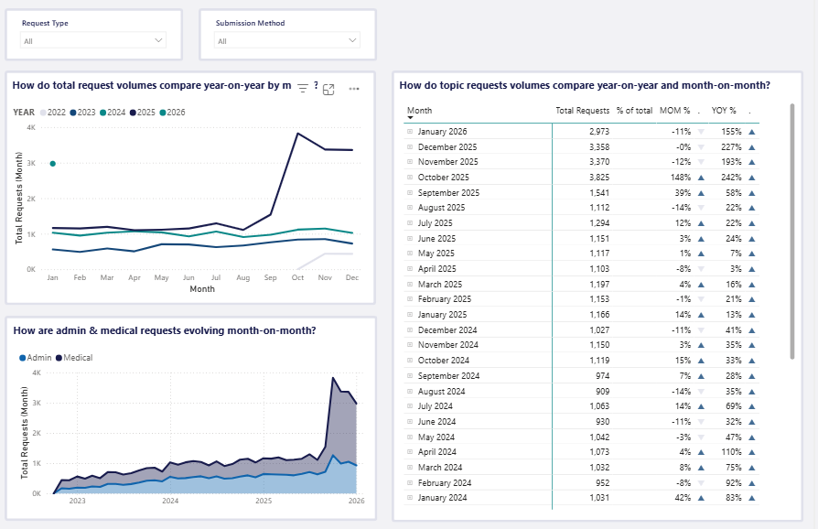

What’s working well
We have already seen several positive changes:
- Shorter telephone waiting times
- Requests can be submitted throughout the working day
- Same-day responses for all requests
- Improved signposting to the most appropriate clinician, including:
  - Clinical pharmacists within the practice
  - Community pharmacies through the Pharmacy First scheme
  - Physiotherapy services
  - Mental health practitioners
Many patients are now receiving care more quickly and without needing to wait for a GP appointment.
Challenges we are continuing to work on
We also recognise some ongoing challenges:
- Fewer routine GP appointments available to book in advance, which can affect continuity of care and long-term condition management
- Clinician fatigue, due to the volume of triage requests reviewed throughout the day
- Additional time required each week to review demand and ensure there is enough capacity
- Patient expectations, particularly around appointment availability and outcomes following triage
What happens next
We continue to review this data regularly and make adjustments where possible. Our aim is to balance:
- Safe and timely access for patients
- Appropriate use of the wider clinical team
- Continuity of care where possible
- Staff wellbeing and sustainability of the service

